

Student Name……………………………………

FURTHER MATHEMATICS

TRIAL EXAMINATION 2

2011

Reading Time: 15 minutes
Writing time: 1 hour 30 minutes

Instructions to students
This exam consists of Section A and Section B.
Section A contains a set of extended answer questions from the core, 'Data Analysis'.
Section A is compulsory and is worth 15 marks.
Section B begins on page 8 and consists of 6 modules. You should choose 3 of these modules and answer every question in each of your chosen modules. Each of the modules is worth 15 marks.
Section B is worth 45 marks.
There is a total of 60 marks available for this exam.
The marks allocated to each of the questions are indicated throughout.
Students may bring one bound reference into the exam.
An approved graphics or CAS calculator may be used in the exam.
Formula sheets can be found on pages 37 and 38 of this exam.
Unless otherwise stated the diagrams in this exam are not drawn to scale.

This paper has been prepared independently of the Victorian Curriculum and Assessment Authority to provide additional exam preparation for students. Although references have been reproduced with permission of the Victorian Curriculum and Assessment Authority, the publication is in no way connected with or endorsed by the Victorian Curriculum and Assessment Authority.

© THE HEFFERNAN GROUP 2011

This Trial Exam is licensed on a non transferable basis to the purchasing school. It may be copied by the school which has purchased it. This license does not permit distribution or copying of this Trial Exam by any other party.

SECTION A

Core

Question 1

This section is compulsory.

Table 1 below shows the number of students with a public transport concession card in each of 16 classes at a particular school.

Class | Number of students with concession card
7A | 5
7B | 9
7C | 4
7D | 3
8A | 5
8B | 12
8C | 19
8D | 5
9A | 6
9B | 22
9C | 14
9D | 25
10A | 17
10B | 6
10C | 11
10D | 7
Table 1

- What percentage of these 16 classes have more students with a public concession card than 9C?

1 mark
The ordered stemplot below displays the data in the table. One value is circled.

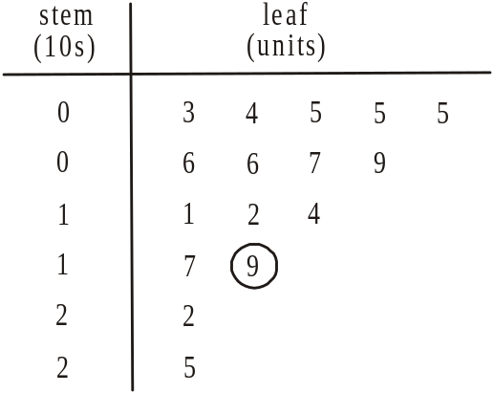

- Which class is represented by this circled value?

1 mark

- What is the median number of students in a class with a public transport concession?

1 mark

- Describe the shape of the distribution.

1 mark

- Explain why the median is a better measure of the centre of this distribution than the mean.

1 mark

Question 2

Table 2 below shows the distance between home and school for 12 students, together with the number of times they were late to school in 2010.

Distance  (km) | Number of  times late
2.2 | 9
0.5 | 11
1.3 | 9
3.7 | 6
0.2 | 13
1.9 | 10
0.8 | 14
2.6 | 8
1.1 | 12
1.7 | 11
4.3 | 7
3.1 | 10
Table 2

The scatterplot below displays the data in Table 2.

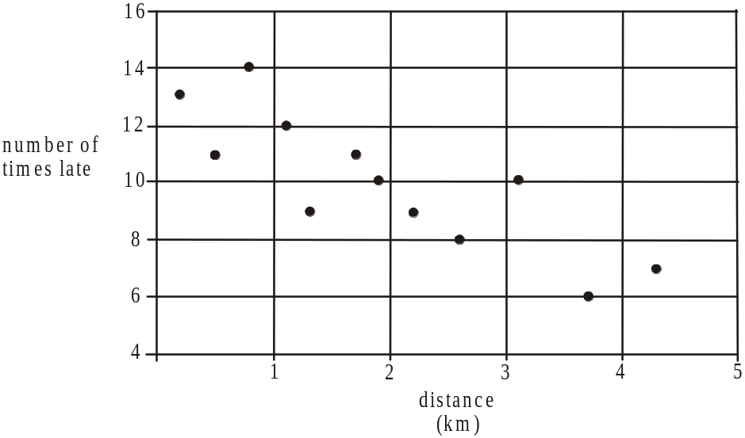

- Calculate the value of r; Pearson’s product moment correlation coefficient for this data. Express your answer correct to 2 decimal places.

1 mark

- What percentage of the variation in the number of times a student is late to school can be explained by the variation in the distance between their home and school? Express your answer correct to the nearest percent.

1 mark

- Use the variables distance and number of times late to write down the equation of the least squares regression line. Express values correct to 2 decimal places where appropriate.

2 marks

The residual plot below was constructed to test whether the assumption that the relationship between the variables distance and number of times late was linear.
The data value for the student who lives 1.9km from school was left off.

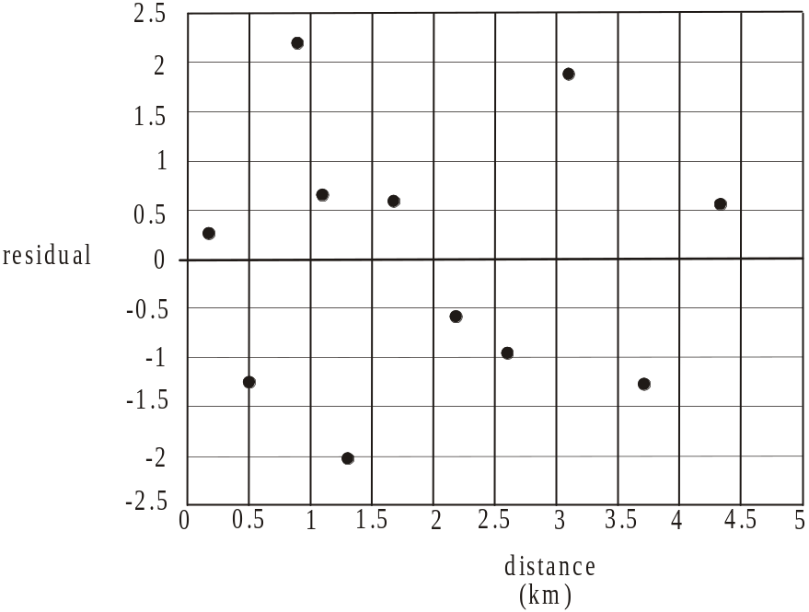

- Using your answer to part c., find the residual value for the student who lives 1.9km from school and clearly plot this value on the residual plot.

1 mark

- Explain why the residual plot supports the assumption that the relationship is linear.

1 mark
Question 3

The time series plot below shows the number of students each year who regularly rode their bike to this particular school between 1991 and 2001.

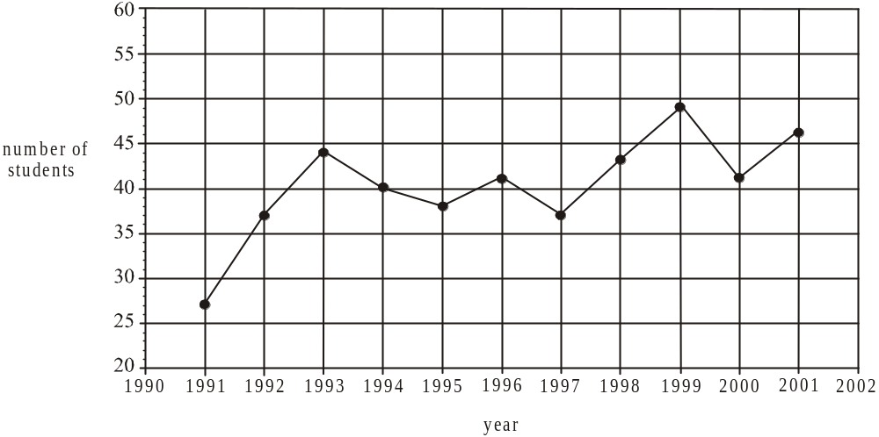

- On the time series plot above, plot a smoothed time series using three-median smoothing. Indicate the smoothed data points with a cross.

2 marks

A trend line is fitted by eye to the time series plot and is shown below.
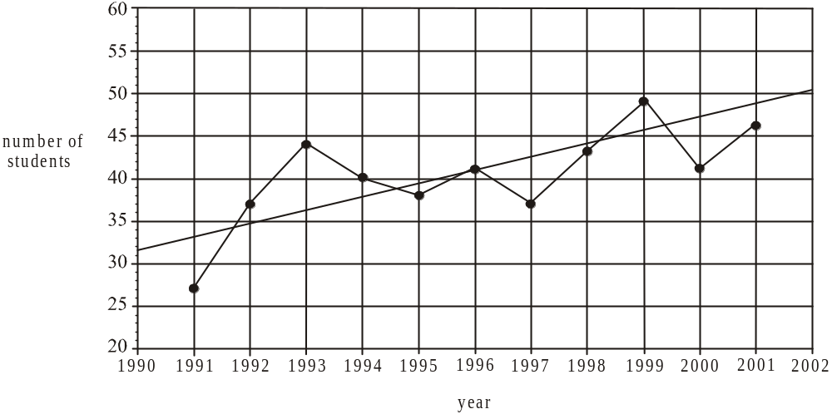

The equation of this trend line is given by

where year number 1 refers to the year 1991, year number 2 refers to the year 1992 and so on.

- What is the predicted number of students riding to school in 2010 according to this trend line? Express your answer to the nearest whole number.

1 mark

- What is the average, annual increase in the number of students riding to school according to this trend line? Express your answer to the nearest whole number.

1 mark
Total 15 marks

SECTION B

Module 1: Number patterns

If you choose this module all questions must be answered.

Question 1

Keisha is purchasing tickets online for a concert. On the Ticketget website the cost of purchasing one ticket is $55, the cost of two is $100, the cost of three is $145, the cost of four is $190 and so on.

- Show that this sequence of costs forms an arithmetic sequence.

1 mark

- How much would it cost to purchase 15 tickets?

1 mark

- Keisha has $1350 credit available on her credit card to purchase the tickets.
What is the maximum number of tickets Keisha can purchase?

1 mark

- The arithmetic sequence of costs can be expressed by the difference equation

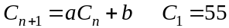

Write down the values of a and b.

2 marks

Question 2

Tickets to the concert are also available on the Dodgeybros website. On this website, the cost of each ticket decreases with each successive ticket purchased in one transaction. The cost of each successive ticket purchased in one transaction forms a geometric sequence with a common ratio of 0.9. The cost of purchasing the first ticket is $65.

- What is the cost of purchasing the 5th ticket in one transaction on this website?

1 mark

- How many tickets must be purchased before the cost of a ticket drops below $20?

1 mark

- What is the maximum amount that can be spent purchasing tickets to the concert on this website? (Assume there are no limits on the number of tickets that can be purchased.)

1 mark

- Keisha needs to purchase 8 tickets to the concert. How much will Keisha save if she purchases the tickets from the Ticketget website described in Question 1 rather than the Dodgeybros website?

2 marks

- If Keisha needed to buy more than 8 tickets, which website would be cheaper to purchase them from. Give a reason for your answer.

1 mark

Question 3

A new website is set up to sell discounted concert tickets. Let S_{n} be the number of tickets predicted to be sold in the n^{th} month after it has been set up. The difference equation that defines S_{n} is

- Find the number of tickets predicted to be sold in the fourth month.

1 mark

- Show that the values generated by this difference equation do not form a geometric sequence.

1 mark

- In order for this difference equation to predict growth in the monthly sales of concert tickets, the number of tickets sold in the first month must exceed 4000. Explain why this is the case using appropriate working.

2 marks
Total 15 marks

Module 2: Geometry and trigonometry

If you choose this module all questions must be answered.

Question 1

The plan below shows the position of some buildings in a ski village. The medical centre is located at M, the supermarket is located at S and the fire station is located at F. These three buildings lie in a straight line running in a north-south direction. The ticket office at T is due east of S. the distance from M to S is 40 metres and the distance from S to T is 70 metres.

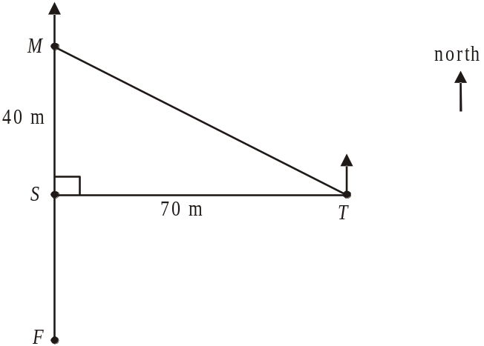

- Find the distance from M to T. Express your answer in metres correct to one decimal place.

1 mark

- Find the angle MTS. Express your answer to the nearest whole degree.

1 mark

- Using your answer to part b., find the bearing of M from T.

1 mark
- The bearing of F from T is 230°. Find the distance from F to S. Express your answer in metres correct to one decimal place.

2 marks

Question 2

The triangular area fenced off for a toboggan run is shown below. The corner points of this area are located at A, B and C where AB is 80 metres, BC is 110 metres and angle BAC is 65°.

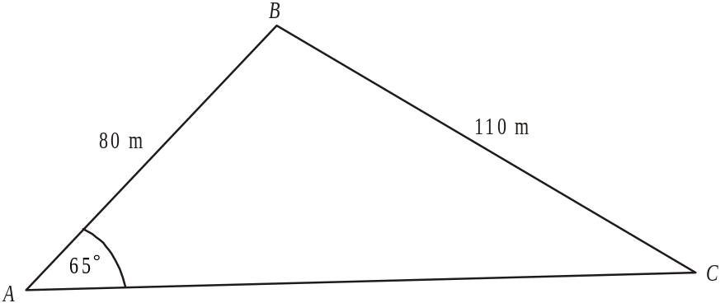

- Find angle ACB. Express your answer in degrees correct to two decimal places.

1 mark

- Use the cosine rule to find the length of the fence along AC. Express your answer in metres correct to one decimal place.

1 mark

- Find the area fenced off for the toboggan run. Express your answer in square metres correct to one decimal place.

1 mark

Xavier starts his toboggan ride at point X which lies on BC and is 40 metres from point B. He travels in a straight line parallel to AB and stops at point Y which lies on AC.

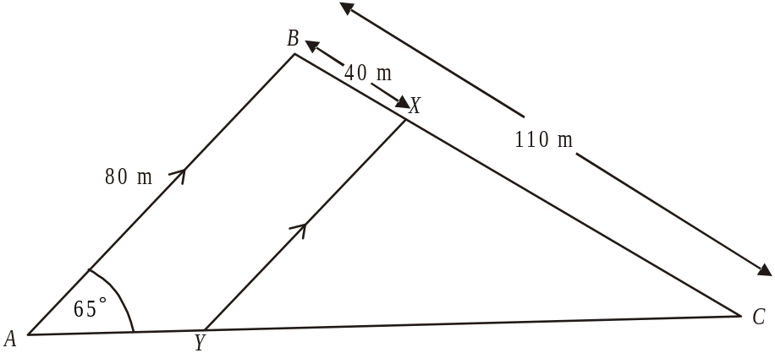

- Find the distance XY. Express your answer in metres correct to one decimal place.

2 marks

Question 3

The concrete foundations for the towers used to support the chairlifts are in the shape of a prism. The dimensions are shown in the diagram below.

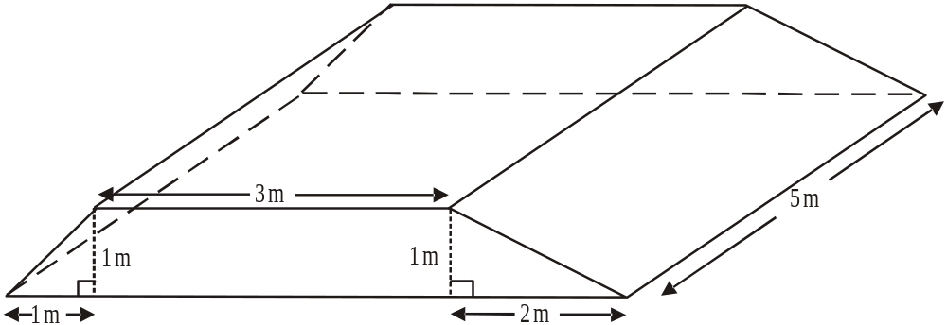

Find the volume of cement required in cubic metres to construct one of these foundations.

2 marks

Question 4

The positions of three identical towers A, B and C that form part of a chairlift are marked on the contour map below.

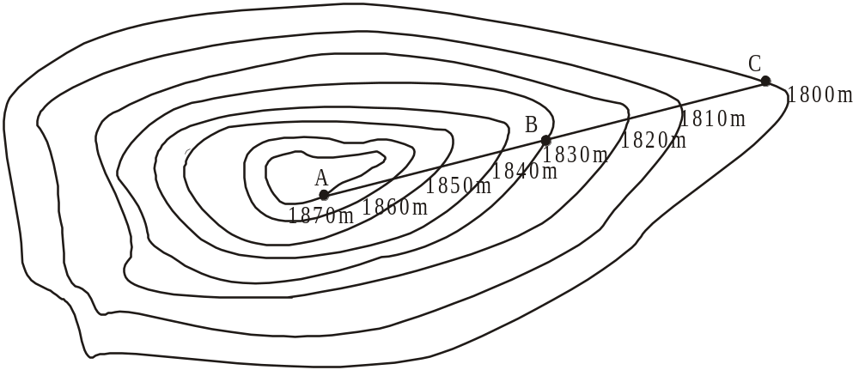

The horizontal distance between the towers at A and B is equal to the horizontal distance between the towers at B and C.
The towers are connected by heavy cable that is kept taut.

- State which section of cable, AB or BC, has the steepest gradient. Give a reason for your answer.

1 mark

- The angle of elevation of point A from point B is 35°. Find the length of cable running between the tower at B and the tower at C. Express your answer in metres correct to one decimal place.

2 marks
Total 15 marks
Module 3: Graphs and relations

If you choose this module all questions must be answered.

Question 1

The height (in metres) of a flooded river over a 12 hour period is shown on the graph below.
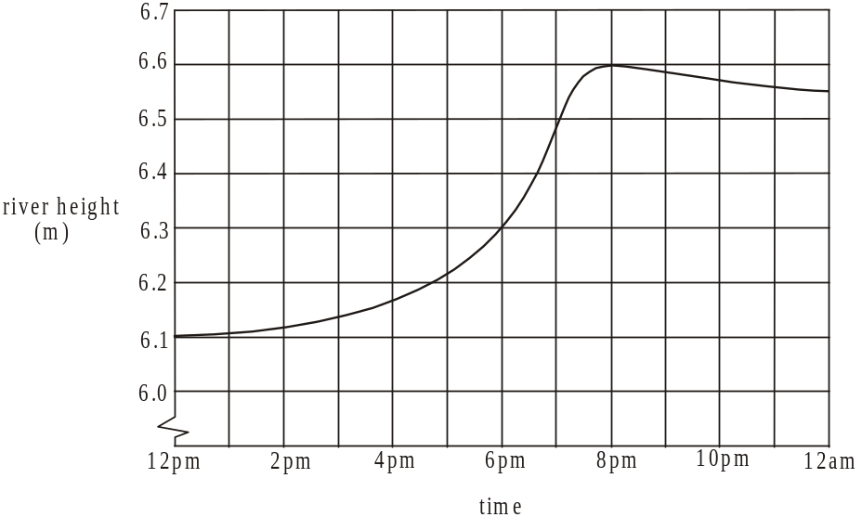

- What was the height of the river at 12pm?

1 mark

- When the river rose to 6.3 metres it broke its banks. At what time did this occur?

1 mark

- For what proportion of this 12 hour period was the height of the river increasing?

1 mark

- What is the average decrease in metres per hour in the height of the river between 8pm and 12am?

1 mark

Question 2

At a nearby caravan park the owner receives $95 per night in revenue for each cabin that is occupied.

- Write an equation for R, the revenue in dollars, received per night when n cabins are occupied.

1 mark

The cost C, in dollars, per night of having n cabins occupied is given by .

- Find the number of cabins that need to be occupied per night for the owner to break even.

1 mark

- One night the caravan owner had 15 cabins occupied.
What was the profit made on this night?

1 mark

- On a different night, the owner made a loss of $200.
How many cabins were occupied on this night?

1 mark

Question 3

The caravan park also offers campsites and on-site-vans that can be rented overnight.

Let the number of campsites rented overnight.
Let the number of on-site-vans rented overnight.

There are certain constraints on the number of campsites and on-site-vans that can be rented overnight. The inequalities below represent these.

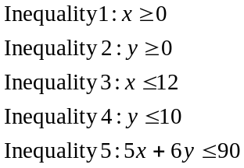

Inequality 5 arises because the amenities block can cope with a maximum of 90 people. As a consequence, a restriction is placed on the number of people who can stay overnight at a campsite or in an on-site-van.

- What is the maximum number of people who can stay overnight in an on-site-van?

1 mark

The lines 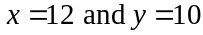 are shown on the graph below.

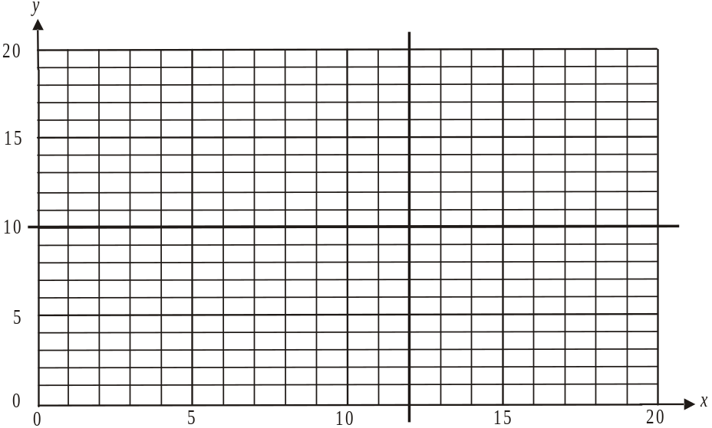

- On the graph above, sketch the graph of 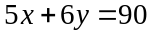.

1 mark

- On the graph above, shade the feasible region using inequalities 1 – 5.

1 mark
The profit made on the overnight rental of a campsite is $40 and for an on-site-van it is $50.

- What is the maximum profit that the caravan owner can make in one night on the rental of campsites and on-site-vans?

2 marks

Renovations to the amenities block mean that a maximum of only 36 people can stay overnight at campsites and in on-site-vans. The maximum number of people who can stay overnight at a campsite is 3 and the maximum number of people who can stay overnight in an on-site-van is 4.

- What is the maximum profit that the caravan park owner can now make in one night on campsite and on-site-van rental?

2 marks
Total 15 marks

Module 4: Business-related mathematics

If you choose this module all questions must be answered.

Question 1

The recommended retail price of a car is $28 000. During June this price is reduced to
$24 500.

- What is the percentage discount applied to this car in June?

1 mark

- A Goods and Services Tax (G.S.T.) must be paid on this purchase at the rate of 10% of the discounted price.
How much G.S.T. is to be paid?

1 mark

Question 2

A car is purchased by a company for $42 000.

- If it is depreciated by 6% of its purchase price each year, what will its book value be after 5 years?

1 mark

- If it is depreciated at a rate of 7.2% per year, what will its book value be after 5 years?

1 mark

- If it is depreciated by 20 cents per kilometre, how many kilometres will it have been driven when its book value reaches $10 000?

1 mark

Question 3

- An amount of $12 000 is invested in an account that earns 4% simple interest calculated annually.
What is this investment worth after 3 years?

1 mark

- If the $12 000 had been invested in an account that earned 4% compound interest calculated annually, what would the investment have been worth after 3 years?

1 mark

- If the $12 000 had been invested at the same interest rate of 4% per annum compound interest over 3 years, how could the value of the investment have been greater than the investment in part b? Show a calculation to justify your answer.

2 marks

Question 4

An amount of $64 000 is invested in an annuity at 6% per annum compound interest compounded monthly.

- Regular monthly payments of $2 000 are to be made to the investor. How long will this annuity last? Express your answer in months to the nearest whole month.

1 mark

- If the investor wanted the annuity to last for 5 years, what would be the monthly payment to the investor?

1 mark

Question 5

A couple borrow $180 000 when they take out a reducing balance loan. The interest rate charged on this loan is 5.2% per annum compounding quarterly.
They can completely repay the loan over a 10 year or a 15 year period.
If they completely repay the loan over a 10 year period, their quarterly repayments will be
$5 799.49.

- If the couple choose to completely repay the loan over a 10 year period, how much will they still owe on the principal after 5 years?

1 mark

- If the couple choose to completely repay the loan over a 15 year period, what will their quarterly repayments be?

1 mark

- How much interest will the couple save by completely repaying the loan over a 10 year period instead of a 15 year period?

2 marks
Total 15 marks

Module 5: Networks and decision mathematics

If you choose this module all questions must be answered.

Question 1

At a music festival there are 7 performing areas and 2 entry/exit points that are linked by a series of paths. The distances, in metres, along the paths linking the performing areas labelled B, C, D, E, F, G, H and the entry/exit points labelled A and I are shown below.

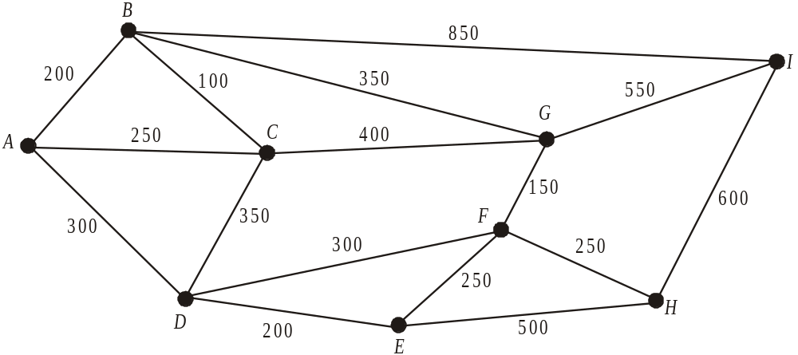

- What is the length of the shortest route from A to I?

1 mark

- Write down one route that starts at A, finishes at I and is a Hamiltonian path.

1 mark

- An Euler path that starts at A and finishes at I will exist if one path linking two performing areas is taken away. Between which two performing areas is this path?

1 mark

- When the music festival first began there were fewer paths. There were just enough paths to ensure that all 7 performing areas and the two entry/exit points were linked and the total distance along these paths was a minimum. On the diagram below, show clearly the paths that existed when the music festival began.

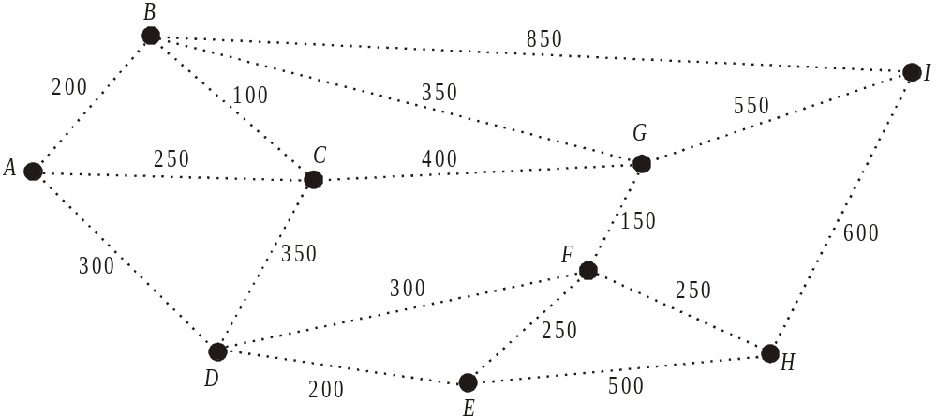

1 mark
Question 2

One of the most congested areas at the music festival is around the performing areas B, C, D, E and F. These performing areas and the paths linking them are shown below.

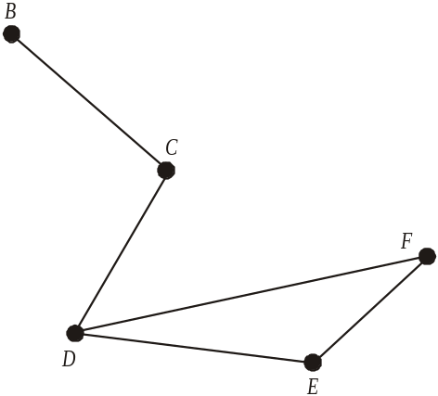

The adjacency matrix below indicates the performing areas that have a path running directly between them.

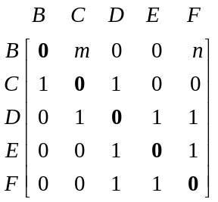

- Explain why the figures in bold on the diagonal of the adjacency matrix above are all zero.

1 mark

- Write down the values of m and n shown in the adjacency matrix above.

1 mark

Question 3

Each performing area is assigned a stage manager. The average time taken in minutes for four stage managers to clear an act’s equipment and get the next act’s equipment ready at four of the performing areas is shown in the table below.

 | performing area
 | B | C | D | E
Kev | 30 | 18 | 30 | 15
Pete | 25 | 15 | 28 | 15
Lucy | 35 | 15 | 25 | 17
Kiran | 38 | 20 | 30 | 16

The festival organisers wish to minimise the time taken between acts and use the Hungarian algorithm to assign a stage manager to a particular performing area.

- The first step of the Hungarian algorithm is shown below for Kev, Pete and Lucy.

 | performing area
 | B | C | D | E
Kev | 15 | 3 | 15 | 0
Pete | 10 | 0 | 13 | 0
Lucy | 20 | 0 | 10 | 2
Kiran

Complete the values in the shaded area of the table for Kiran.

1 mark

- Using the remaining steps of the Hungarian algorithm, find which performing area Kiran should be allocated to.

2 marks
Question 4

There are 10 activities, A – J, that need to be completed to set up the infrastructure for the music festival.
These activities; together with their earliest start time (EST), latest start time (LST), duration (in days) and immediate predecessor(s) are shown in the table below. The EST for activity G has been omitted and the LST for activity H has been omitted.

Activity | Duration  (days) | EST  (days) | LST  (days) | Immediate  Predecessor(s)
A | 3 | 0 | 5 | -
B | 4 | 0 | 3 | -
C | 4 | 0 | 0 | -
D | 6 | 3 | 8 | A
E | 3 | 4 | 4 | C
F | 5 | 4 | 8 | C
G | 7 |  | 7 | B, E
H | 6 | 7 |  | B, E
I | 6 | 9 | 13 | F
J | 5 | 14 | 14 | D, G

- Find the earliest start time (EST) for activity G.

1 mark

- Find the latest start time (LST) for activity H.

1 mark

- What is the float time for activity F?

1 mark

- Which activities are critical to setting up the infrastructure in the shortest possible time?

1 mark

- What is the shortest time possible in which the infrastructure can be set up?

1 mark

- Activity B has a major hold up and will now have a duration of 8 days. What is the shortest time possible now, in days, for the infrastructure to be set up?

1 mark
Total 15 marks

Module 6: Matrices

If you choose this module all questions must be answered.

Question 1

At a gymnasium, there are 4 types of membership; full (F), restricted (R), junior (J), and part-time (P).
The number of these different types of memberships held this month at the gym, are shown in the matrix M below.
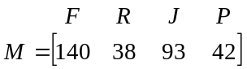

- Write down the order of matrix M.

1 mark

- The cost of monthly membership for full, restricted, junior and part-time members is $200, $120, $80 and $100 respectively.
Express these costs, in the order given, in a column matrix named C.

1 mark

- Find the matrix product MC.

1 mark

- What does the matrix product MC represent?

1 mark
Question 2

The gym runs cardio, jump and zumba classes at each of three levels, introductory, mainstream and advanced.
Members can bring along a friend to these classes by purchasing a guest pass. The number of guest passes sold last month in each of these classes is shown below.

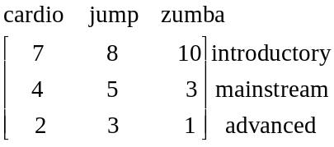

- How many guest passes were sold last month for mainstream zumba classes.

1 mark

The revenue earned by the gym for guest passes to classes last month in cardio, jump and zumba was $440, $209 and $103 respectively.
The cost of a guest pass to a cardio class is $x, to a jump class is $y and to a zumba class is $z.
The values x, y and z can be found by solving the matrix equation below.

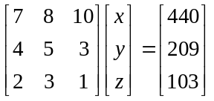

- Solve the matrix equation above and hence find the cost of a guest pass to a cardio, jump and zumba class.

2 marks
Question 3

The gym has 90 people who have signed up for weekly yoga classes. They can attend a yoga class either in the morning (M), at lunchtime (L) or in the evening (E).
In the first week of classes, 30 people attend the morning class, 20 people attend the lunchtime class and 40 attend the evening class.
The state matrix S₁, showing the number of people attending morning, lunchtime and evening yoga classes in the first week is shown below.
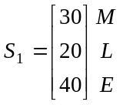
The diagram below shows the percentage of people each week who change from one time to a different time for their yoga class each week.
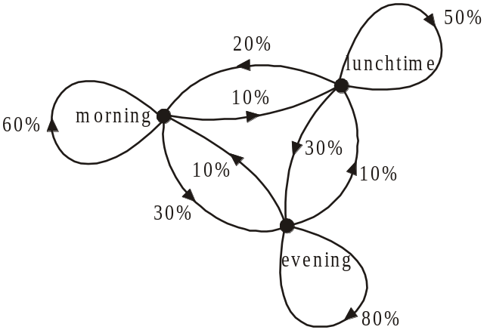

- What percentage of people each week change from a lunchtime yoga class to an evening yoga class?

1 mark

The information in the diagram can be represented by the transition matrix T below.

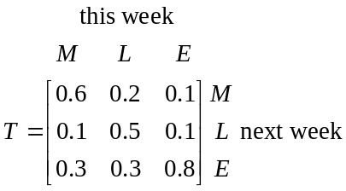

- How many people will be in the evening yoga class in the second week?

1 mark

- How many people will be in the lunchtime class in the 4th week? Express your answer to the nearest whole number.

1 mark
- Any class that drops below 12 people is discontinued.
Explain whether or not any of the classes are discontinued.

2 marks

Question 4

Two cardio classes are run at the same time on Sundays. One is run by Barry and the other by Tina.
The matrix 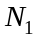 below shows the number of people who went to each of the classes the first week that they ran.
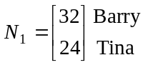

The number of people in the classes in the second week is given by

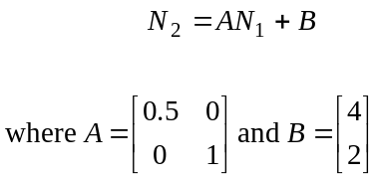
- Find 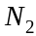.

1 mark

The number of people in each of the classes can be found using the matrix equation

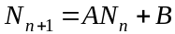

where 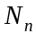 gives the number of people in the classes in the nth week.

- What is the difference in the sizes of the two classes in week 4?

2 marks
Total 15 marks
Further Mathematics Formulas

Core: Data analysis
standardised score: 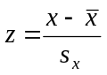
least squares line: 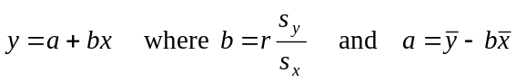
residual value: residual value = actual value – predicted value

seasonal index: seasonal index 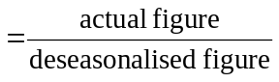

Module 1: Number patterns
arithmetic series: 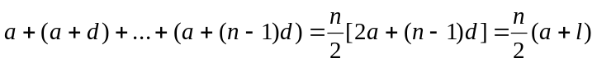
geometric series: 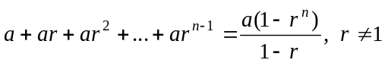
infinite geometric series: 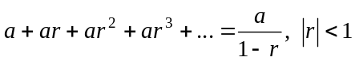

Module 2: Geometry and trigonometry

area of a triangle: 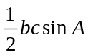
Heron's formula: 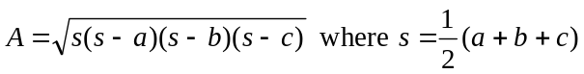
circumference of a circle: 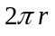
area of a circle: 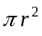
volume of a sphere: 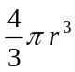
surface area of a sphere: 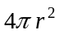
volume of a cone: 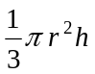
volume of a cylinder: 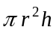
volume of a prism: 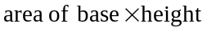
volume of a pyramid: 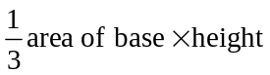

Reproduced with permission of the Victorian Curriculum and Assessment Authority, Victoria, Australia.
These formula sheets have been copied in 2011 from the VCAA website www.vcaa.vic.edu.au
The VCAA publish an exam issue supplement to the VCAA bulletin.
Pythagoras’ theorem 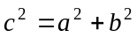
sine rule: 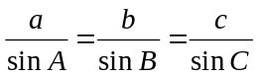
cosine rule: 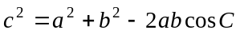

Module 3: Graphs and relations

Straight line graphs

gradient (slope): 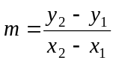
equation: 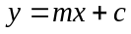

Module 4: Business-related mathematics

simple interest: 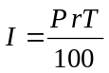
compound interest: 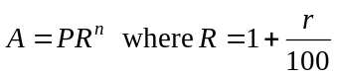
hire purchase: 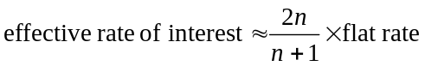

Module 5: Networks and decision mathematics

Euler’s formula: 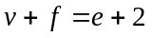

Module 6: Matrices

determinant of a 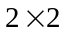 matrix 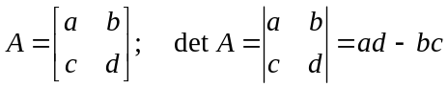
inverse of a matrix 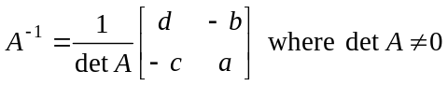

END OF FORMULA SHEET

Reproduced with permission of the Victorian Curriculum and Assessment Authority, Victoria, Australia.
These formula sheets have been copied in 2011 from the VCAA website www.vcaa.vic.edu.au
The VCAA publish an exam issue supplement to the VCAA bulletin.

